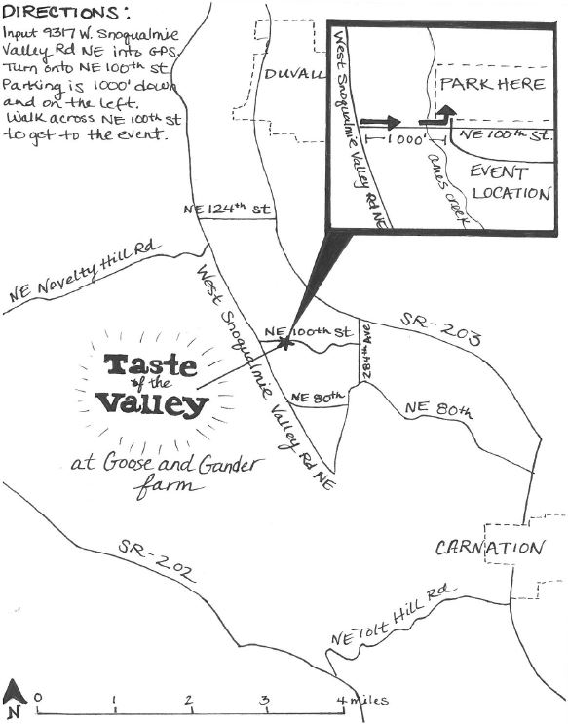
Taste of the Valley - July 28th 2018

